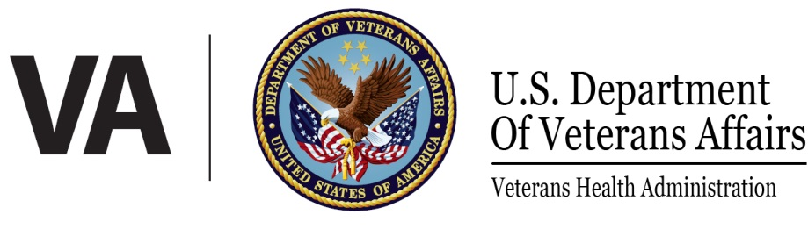 | Media Advisory
Veterans Health Care System of the Ozarks
1100 N. College Ave.
Fayetteville, AR 72703

For Further Information Contact:
Wanda Shull, Public Affairs Officer
Phone: 479-444-4087
Cell: 479-790-9068

VA Announces Concerns with Pathology Readings

Fayetteville, AR - On October 13, 2017, leadership at the Veterans Health Care System of the Ozarks received reports of possible impairment of a staff pathologist. The pathologist was assessed through Employee Health and found unable to work and was immediately removed from clinical practice, and has since been terminated.
As a result, the decision has been made to conduct a thorough review of all cases read by the pathologist by an external review team. These independent reviews are being done to ensure the safety of all patients who may be impacted. This team is also charged with developing clear procedures for addressing this matter, including establishing a methodology for tracking second reviews of tests and protocols to notify affected patients.

“As a Veteran and patient of this facility, quality and safety are very important to me,” said
Kelvin L. Parks, Interim Medical Center Director. “The pathologist was immediately removed from clinical care when evidence of impairment was found. Actions affecting the care and safety of our patients will not be tolerated at Veterans Health Care System of the Ozarks. I am confident that the external review team’s methodology will help us identify affected patients and improve our processes and systems moving forward.”

Due to the high volume of cases being reviewed, this process will take several months to complete. The VA will be reaching out directly to any patient found to be impacted, and has arranged a fully staffed call center and toll free number to answer questions regarding this serious matter. Patients with questions can call (866) 388-5428 or (479) 582-7995. This call center will be staffed Monday-Friday from 8 a.m. to 7 p.m.; and Saturday from 8:00 a.m.to noon to ensure anyone who has questions will be able to speak to someone in person.

# # #
The Veterans Health Care System of the Ozarks (VHSO) consists of one Veterans Health Administration (VHA) facility located in Fayetteville, Arkansas. VHSO has Community-Based Outpatient Clinics (CBOCs) in Fort Smith, Harrison and Ozark, Arkansas; Branson and Mount Vernon, Missouri; and Jay, Oklahoma. VHSO is a 78 authorized bed facility providing various inpatient, outpatient specialty care, and primary care services. VHSO has a 4 star quality rating on SAIL, is a Robert W. Carey Award Circle of Excellence Winner (2013), as well as the 2013 recipient of the Arkansas Governor’s Quality Award.

